1. Frontend (Node.js with Express):
- Create a frontend using Express and Node.js.
- Include a form similar to the one from the Flask Assignment 2.
- Configure the form to send a request to the Flask backend.
- Backend (Flask):
- Use the Flask backend to handle the form submission and process the data.
- Folder Structure:
- Organize the project with separate folders for the frontend and backend.
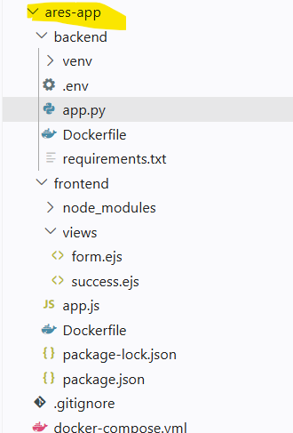

- Docker Configuration:
- Create a Dockerfile for both the frontend and backend.
- Write a .yaml file (Docker Compose) to connect both services in the same network.
- Upload both images to docker hub and push your whole code to github and add the node_modules and other non required files(.vscode) in .gitignore

Link - https://github.com/Toto3107/flaskp
Submission Guidelines -: 1. Upload the terminal screen shots and all your project
code or files on github.
2. Share your github repo link
Output:
Frontend:
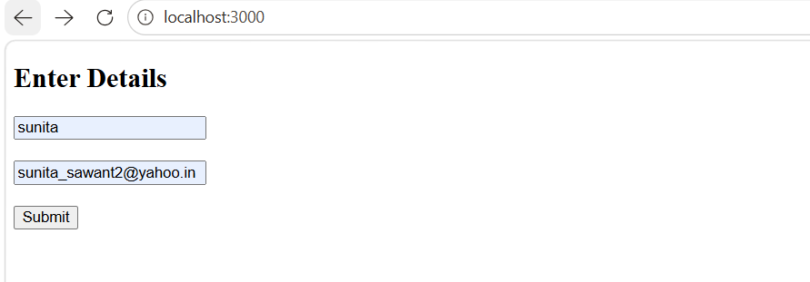

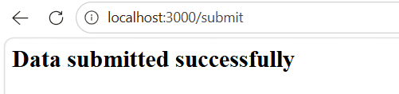
Backend:
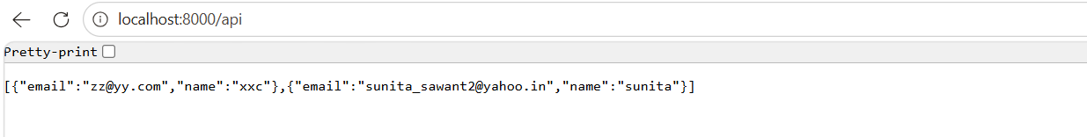
Mango db:

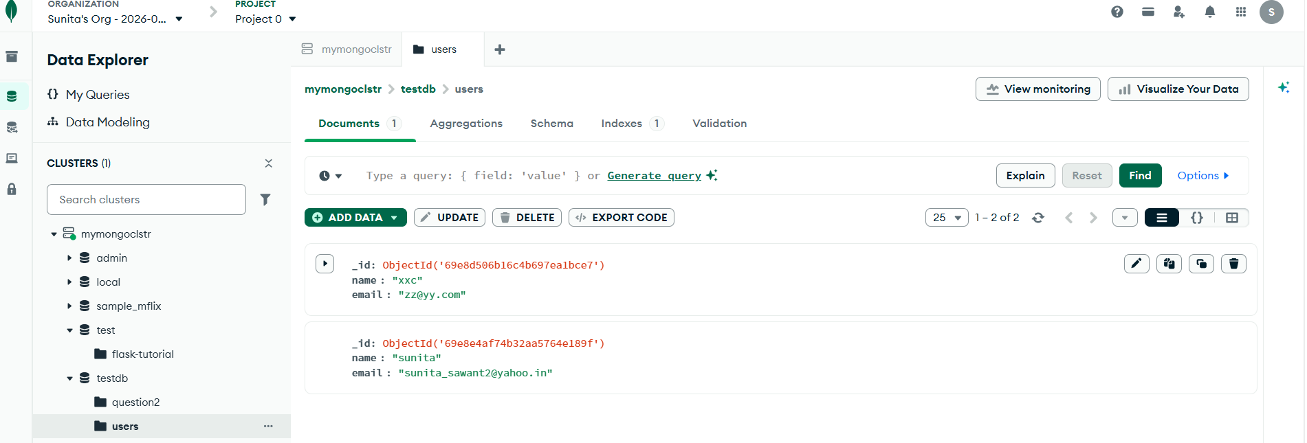

Project pushed on git hub.
sunita-sj/ares-app-doc-assigment5: assignment 5
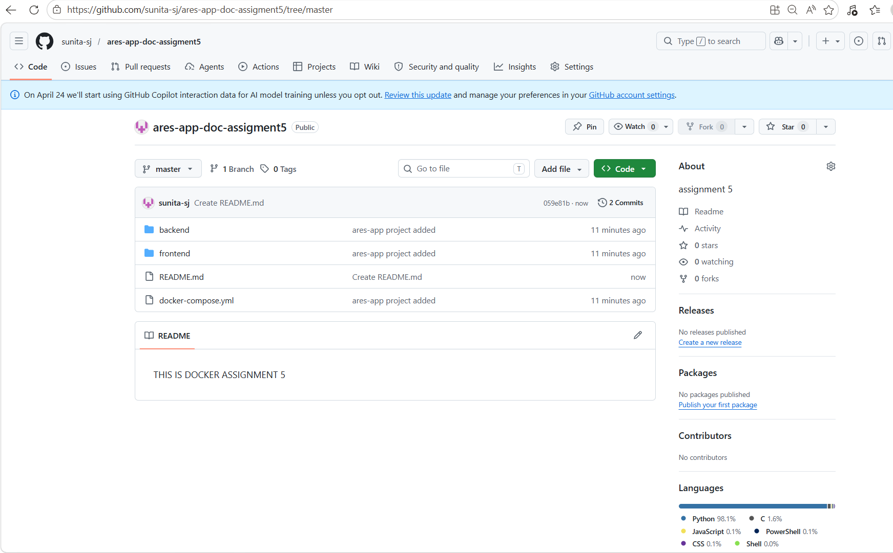

upload this image on Docker hub.

